**Creative Block**

As a part of our STEAM (Science, Technology, Engineering, Arts, and Math) school focus each child participates in up to five electives throughout the school year. All students were given a preview of each Creative Block offering. Students in grades 3-6 were then given ranking sheets and they selected the Creative Block Classes they wanted to participate in.

Kindergarten- Second Grade Creative Blocks

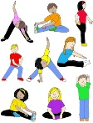**Physical Fitness**- includes cardiovascular and muscular endurance, strength, and flexibility through activities such as Step Box, Spinning, Mindful Movement, and Exercise Balls

**Mindful Movement**- increases flexibility, endurance, and relaxation through purposeful movement and breathing

Visual Arts- creating creatures, such as Monsters, Aliens, and Animals through the use of shapes

**Visual Arts**- development of a 3D character, including its habitat and storyline, which is designed by the students

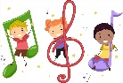**Story time**- students will participate in author and book studies that will incorporate crafts and drama

**Technology**- students will begin exploring coding and problem solving through technology

**Movement and Music**- students will sing, dance and dramatize around topics covered in their academic classes

**Orff Ensemble**- students will create and perform music on a variety of classroom instruments (xylophones, glockenspiels, hand drums)

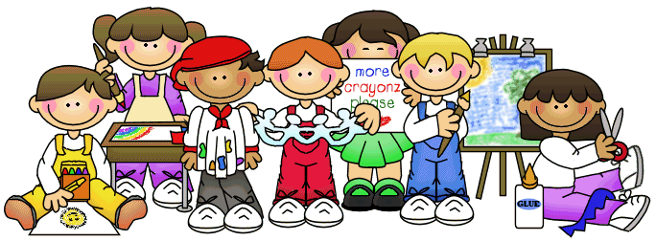

Third and Fourth Grade Creative Blocks

**Paper Arts**- students will learn the history of paper arts and create their own paper to use in unique art projects

**3D Art**- students will use clay, paper Mache, and wood to create 3D art

**Choir**- students will perform music from a variety of cultures in a large choir three times a year; they will also learn how to read music and students will also learn about the background of the pieces they perform

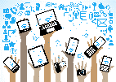Science of Sound- students will explore sound and acoustics through reading, writing, and experiments

**Instrumental Music and Band**- students will learn proper care of instruments, how to read music, and participate in weekly lessons

**Maker Space**- students will use materials and tools to create collaborative projects that are developed through each student’s interests

**Technology**- students will explore coding and problem solving through technology, learn through the use of virtual reality, and create with the use of a 3D printer

Fifth and Sixth Grade Creative Blocks

**Theater**- students will learn about theater production and perform a full musical in the Spring

**Choi**r- students will perform music from a variety of cultures in a large choir three times a year; they will also learn how to read music and students will also learn about the background of the pieces they perform

**Physical Fitness**- includes cardiovascular and muscular endurance, strength, and flexibility through activities such as Step Box, Spinning, Mindful Movement, and Exercise Balls

**Instrumental Music and Band**- students will learn proper care of instruments, how to read music, and participate in weekly lessons

**3D Art**- students will use clay, paper Mache, and wood to create 3D art

**Technology**- students will explore coding and problem solving through technology, learn through the use of virtual reality, and create with the use of a 3D printer